ADDING REQUIREMENT FIELD COLUMNS TO VIEW ADDITIONAL DETAILS ABOUT THE REQUIREMENTS

When you click on requirements module, All you see is Name, Req ID, Direct Cover Status and Author

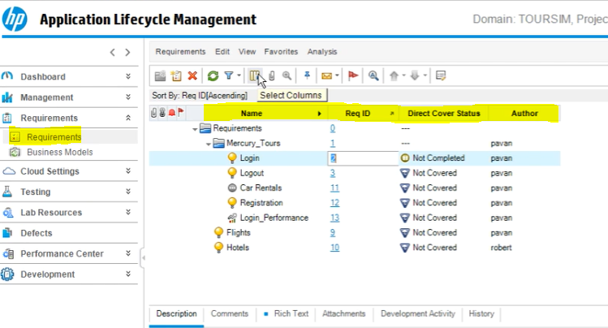

Click on select columns icon

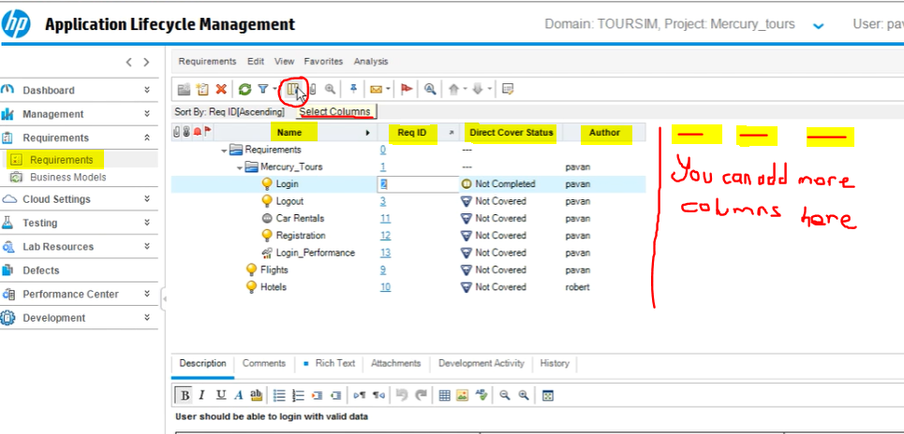

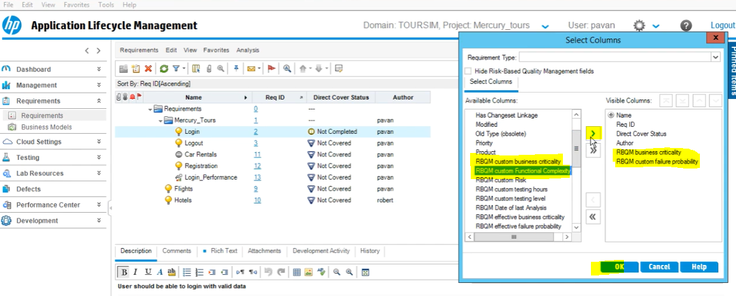

Select the ones you would like to see in requirement module and click on green arrow then ok

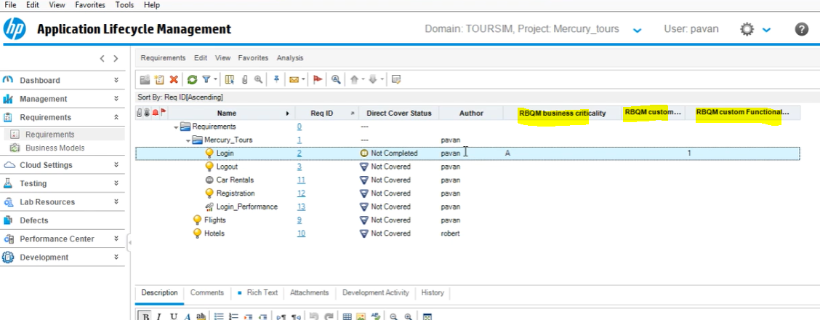

If you would like to change column palaces

Click on the add column icon

Click on the column you want to move then

Click on up and down arrow icon to change the location of the column

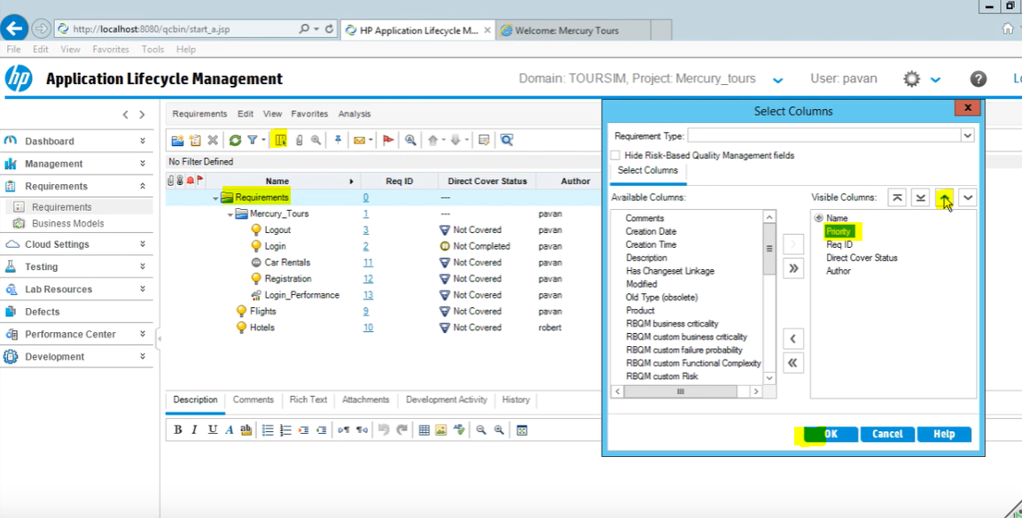

Click OK

